Week 2 Lab Task
Information Gathering (OSINT)
NIAI NAVTTC — Certified Ethical Hacker (CEH) Course
⚠ Important: All tasks must be performed only in your isolated virtual lab environment. Never test on real networks or systems without explicit written permission.

Task: Investigate a suspicious domain. Analyze domain registration details, check for potential malicious activities, and provide actionable intelligence for an incident response team.

▶ Choose a Safe Practice Domain
Use testphp.vulnweb.com — this is a deliberately vulnerable site made for training.
DO NOT target real websites or domains without explicit written permission.
▶ WHOIS Lookup — Find Domain Owner
Run in Kali terminal:
whois testphp.certifiedhacker.com
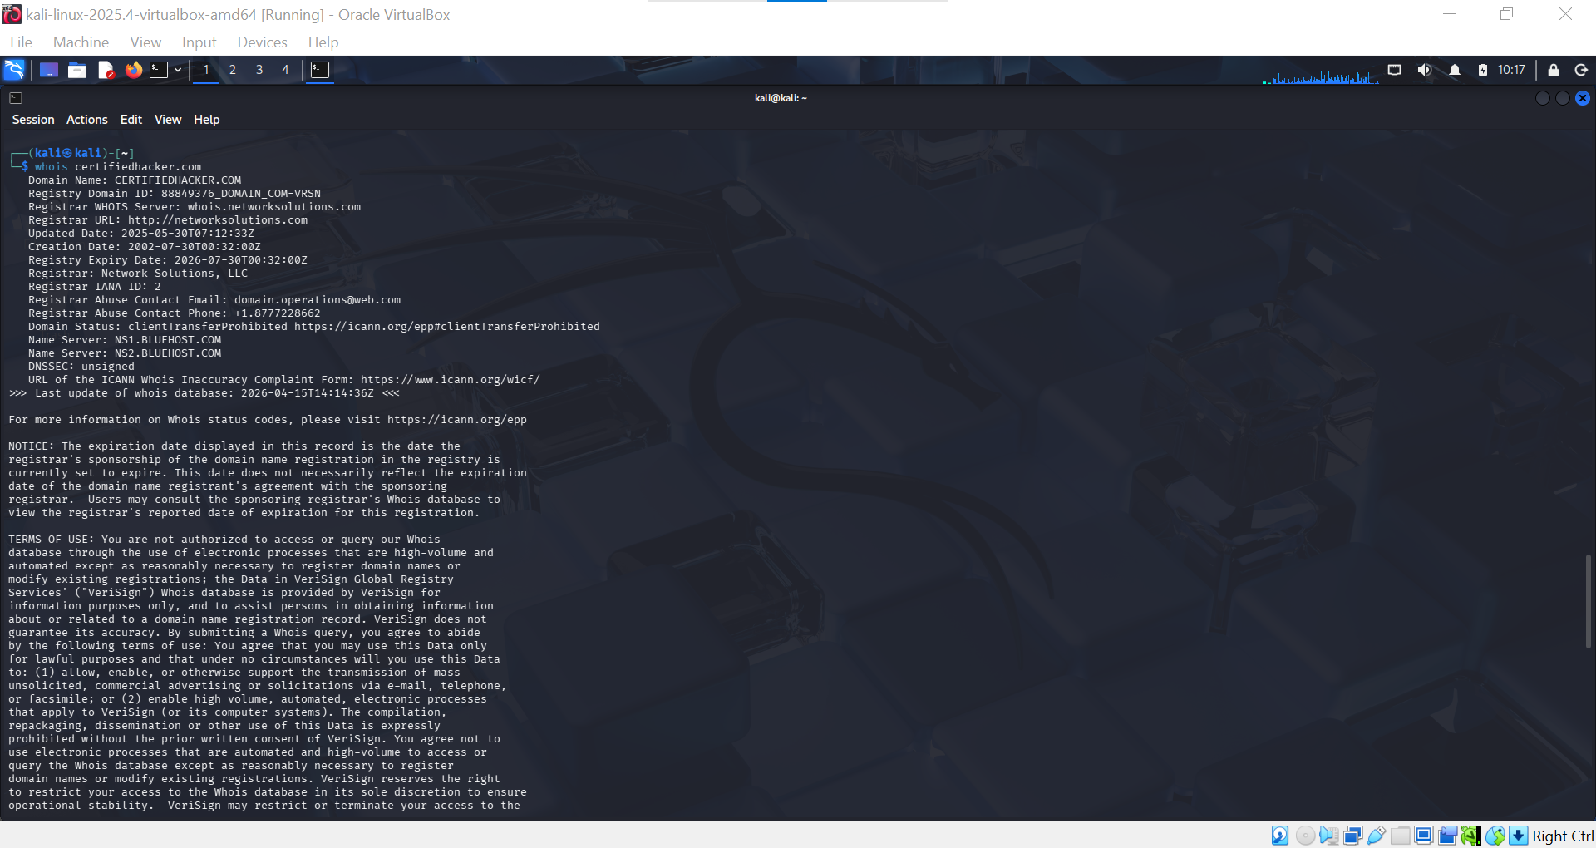

Note the registrar, creation date, name servers, and contact details.
▶ DNS Enumeration
nslookup certifiedhacker.com
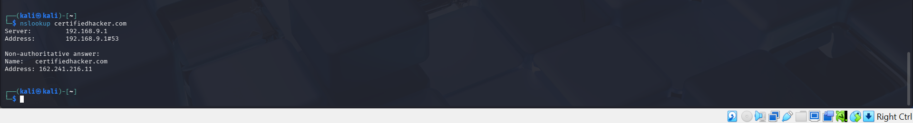
host testphp.vulnweb.com
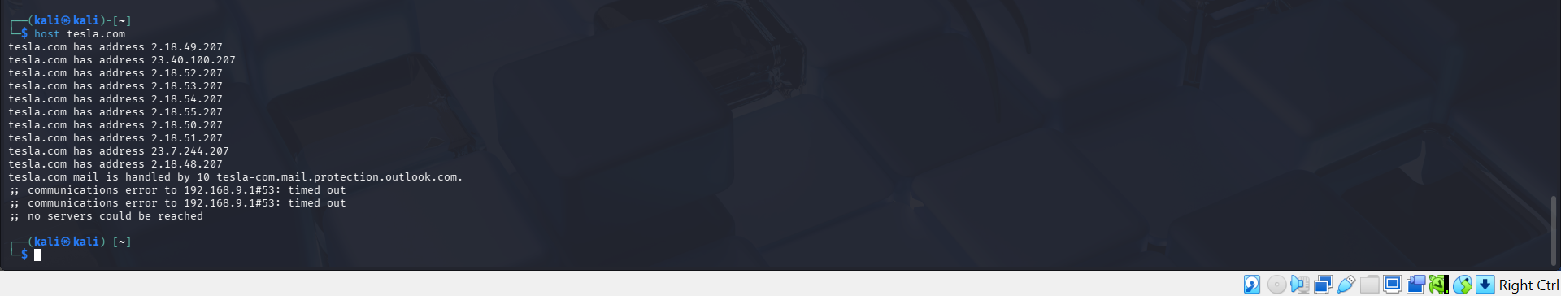
▶ theHarvester — Gather Emails & Subdomains
theHarvester -d example.com -b google
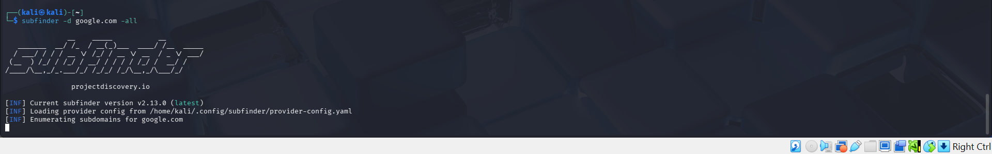
Replace example.com with your target domain. This finds emails and subdomains indexed by Google.
▶ Shodan — Check Exposed Services
Go to shodan.io in your browser.
Search the domain name or its IP address.
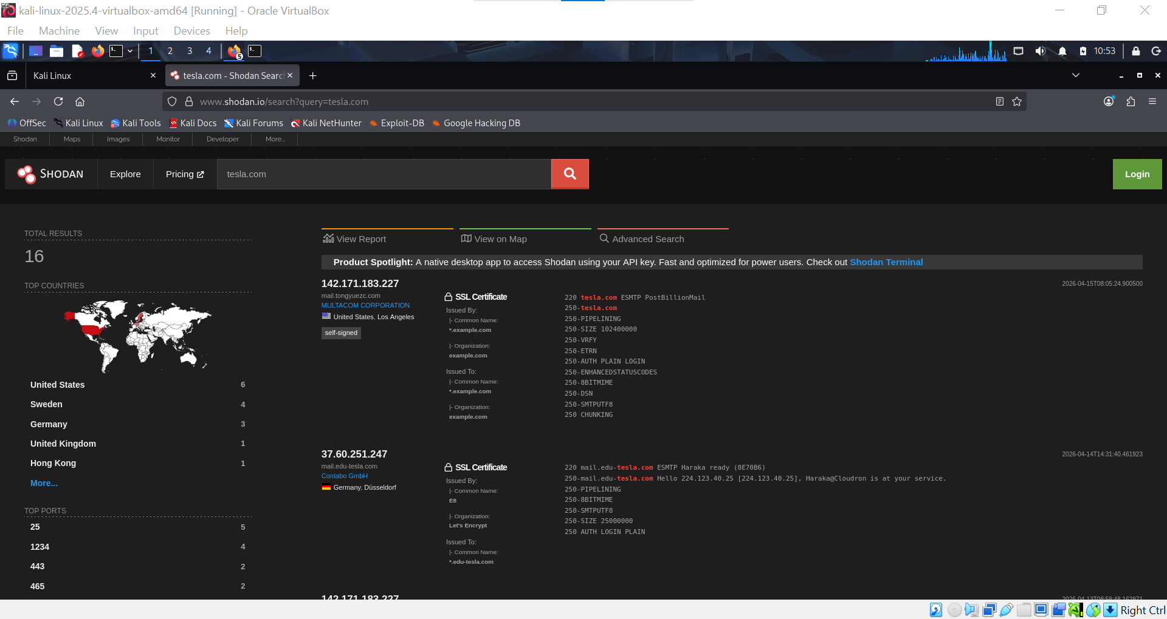
Note what ports and services are publicly visible (e.g. open port 22, 80, 443).
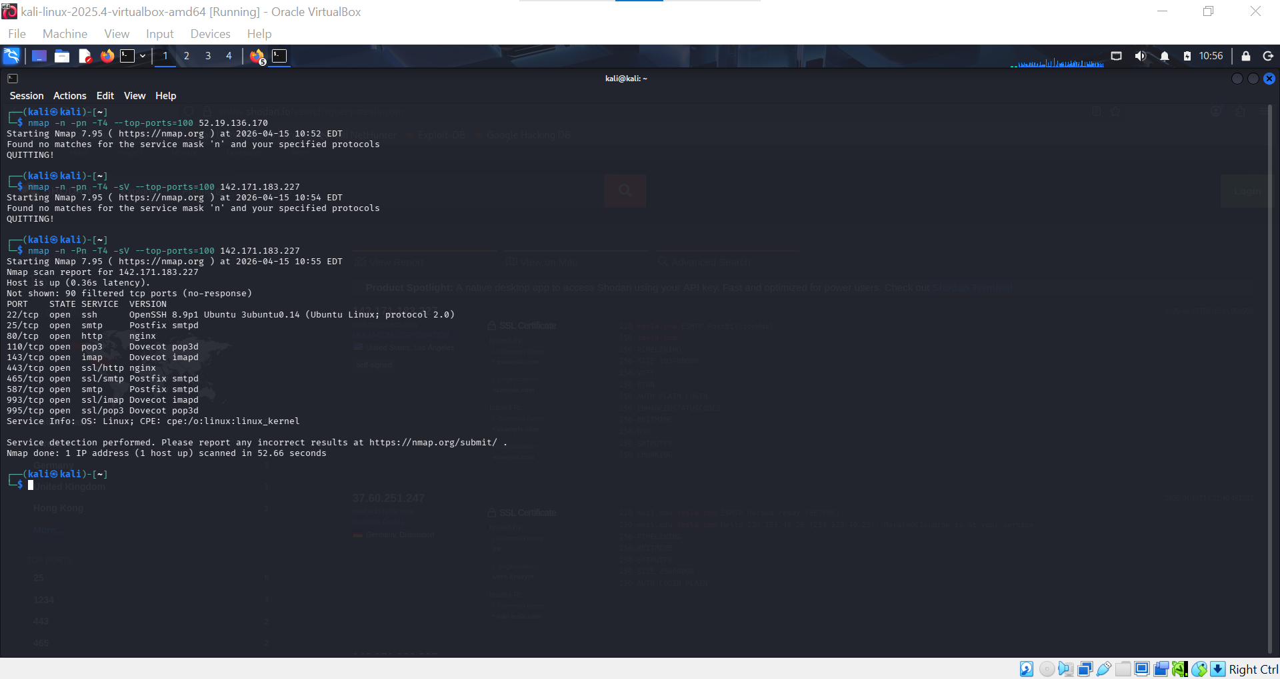
▶ Google Dorks — Find Indexed Pages
In Google browser, search:
site:testphp.vulnweb.com
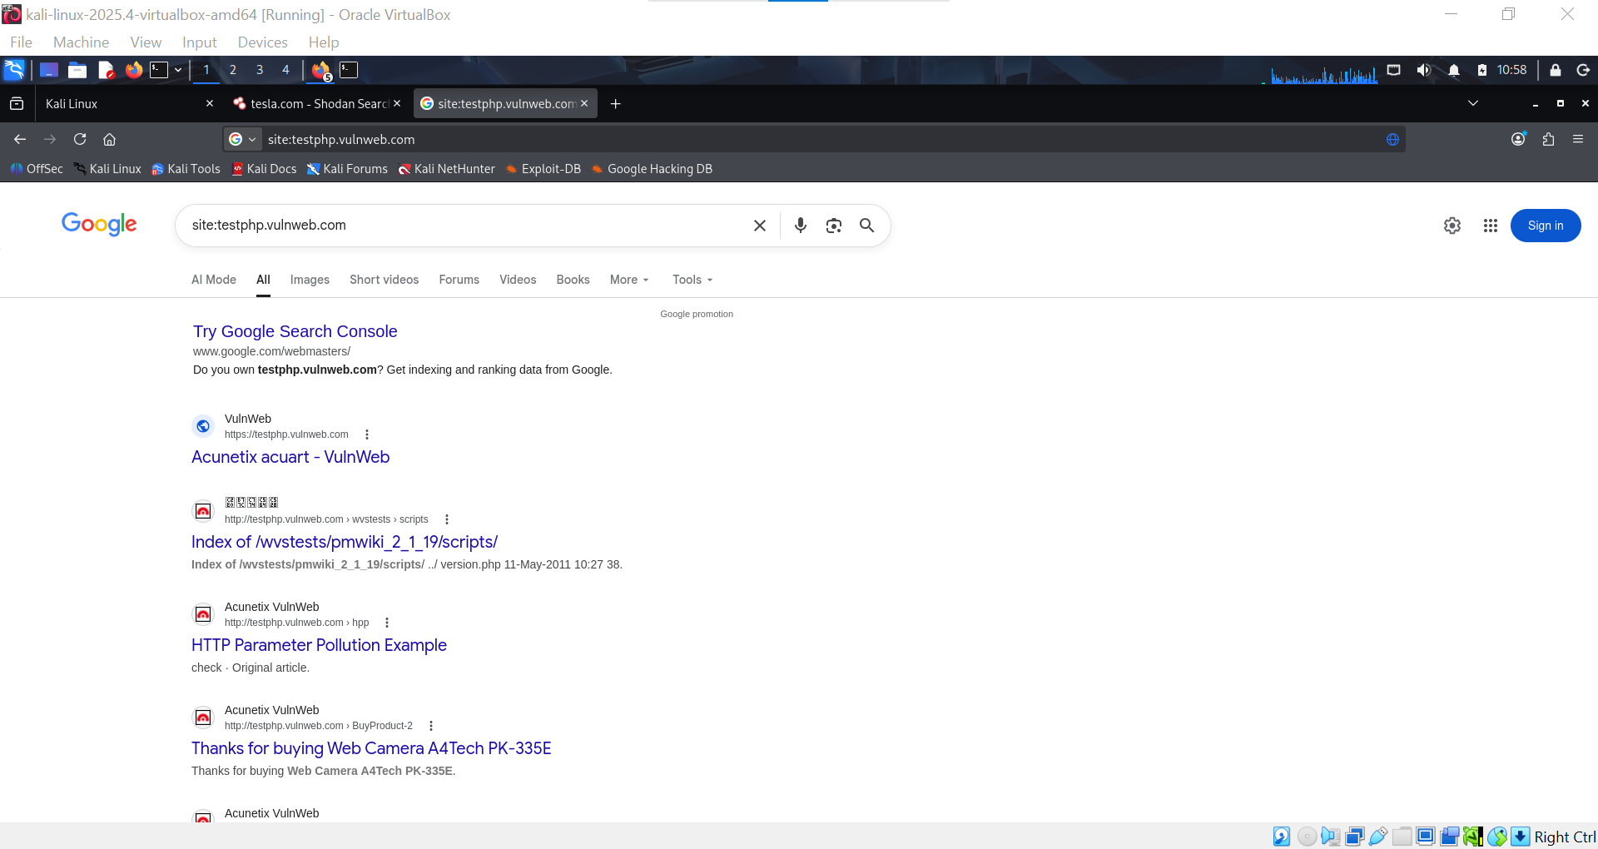
intitle:index.of testphp.vulnweb.com
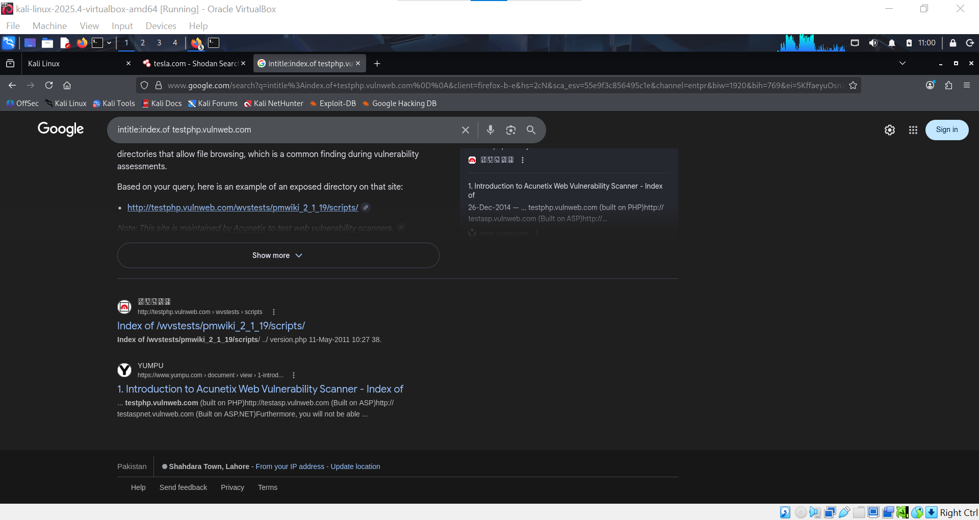
▶ Maltego (Optional — Visual Link Analysis)
Open Maltego from Kali applications menu.
Create a new graph and add the target domain as an entity.
Run transforms to visually map emails, IPs, and subdomains.
▶ Write Your Intelligence Report
Document the following findings in a structured report:
- Who owns the domain? (WHOIS data)
- Registrant Organization: Tesla, Inc.
- Domain Registrar: MarkMonitor Inc. (commonly used by large enterprises)
- Country: United States
- Domain Status: Active, high-security corporate domain
- Privacy: Some WHOIS details are partially protected (enterprise-level protection)
- What IP addresses are associated?
Tesla.com does not rely on a single fixed IP
Uses CDN / cloud infrastructure (load-balanced systems)
IPs can change dynamically depending on:
- User location
- Traffic routing
- Security layer (WAF/CDN)
- What emails or subdomains were found?
support@tesla.com
press@tesla.com
security@tesla.com
sales@tesla.com

Subdomains
- www.tesla.com
- auth.tesla.com
- api.tesla.com
- shop.tesla.com
- accounts.tesla.com
- owner.tesla.com
- static.tesla.com

- What ports/services are exposed on Shodan?
80 HTTP (redirects to HTTPS)
443 HTTPS (main service)
No major direct exposure of:
- SSH (22)
- FTP (21)
- Database ports (3306, 5432)

- Any suspicious indicators?
No major public misconfigurations
Strong security headers (HSTS, TLS enforcement)
Very limited exposed services

🎯 Goal: Produce a structured intelligence report on a domain including ownership, DNS records, exposed services, and any suspicious indicators of compromise.

